Minnstate MoveIt Securely
Official URL: https://services.smsu.edu/TDClient/180/Portal/KB/Article/4067/Minnstate-MoveIt-Securely
Category: Knowledge Base > Information Technology Services > Software and Applications > Minnstate MoveIt Securely
Tags: FileTransfer, FTP, MoveItSecurely
_____________________________________________________
MoveItSecurely is a software application available to all Minnstate employees and students. It is designed to help organizations safely share sensitive data between systems, staff, and users. You can utilize it to move data to another SMSU employee or student safely and without worry. Click here to access Minnstate MoveItSecurely or copy and paste https://securefileshare.minnstate.edu/ in your browser. In this article we have provided instructions on:
- How to send secure mail through Minnstate MoveItSecurely
- MoveItSecurely Recipient Information, and
- How to setup MFA for MoveItSecurely

How to send secure mail through Minnstate MoveItSecurely
Before transferring any data if you are unsure if the data is considered Directory, Non-Directory, or Private Data, you may contact:
- Deb Kerkaert
Data Practices Compliance Official (DPCO)
VP for Finance and Admininstration
- Dan Baun
Chief Information Officer
- Eric White
for student records
Registrar/School Certifying Official
- Laura O’Rourke
for employee records
Campus Human Resources Officer
To move any Data not considered Directory Data off campus, please contact the Data Management and Institutional Research group.
- Use your StarID and password to log in.
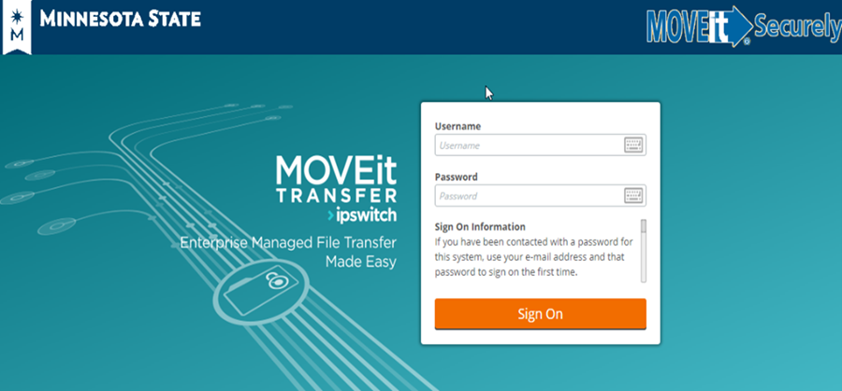
Figure 1: Screenshot
- Choose Packages from the left corner of the page.
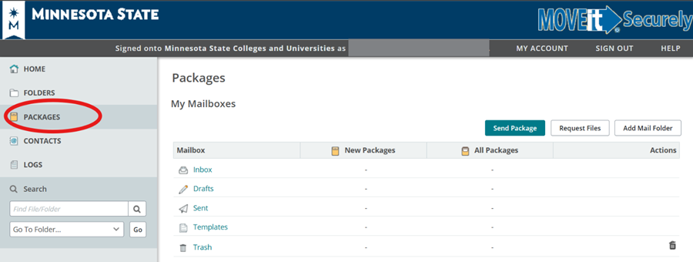
Figure 2: Screenshot
- Choose Send Package.
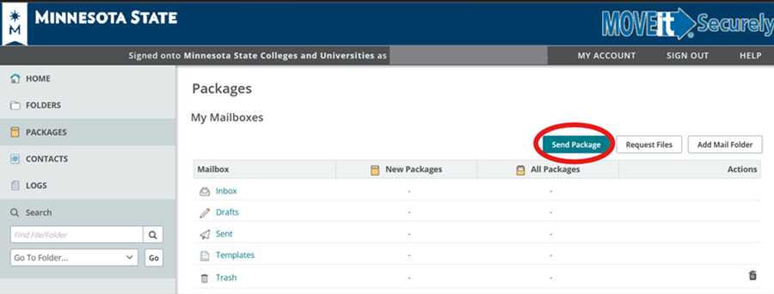
Figure 3: Screenshot
- The following screen will appear.
If the person is from SMSU, click on the “To” and the SMSU address book will appear. Then click on the name you want and click OK. You can also search by first or last name.
If the person is from SMSU and you did not find their name in the search or the person is not from SMSU, go to the "To" line and paste their email address in.
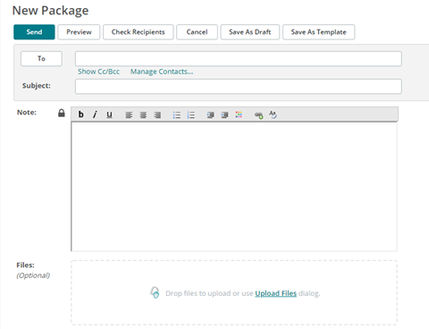
Figure 4: Screenshot
- If the person is from SMSU, click on the “To” and the SMSU address book will appear. Then click on the name you want and click OK. You can also search by first or last name.
- If the person is from SMSU and you did not find their name in the search or the person is not from SMSU, go to the "To" line and paste their email address in.
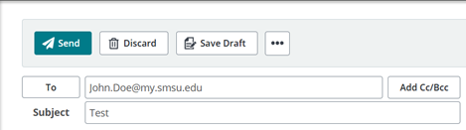
Figure 5: Screenshot
- Type in the Subject and any Notes
- Click on Upload Files and find the file you wish to attach. You can add more than 1 file.
Options: Here is where you can set when the package will expire. The max days to set a package before it expires is 14 days. After the package expires, it will disappear from your sent items and from the receiver’s inbox.
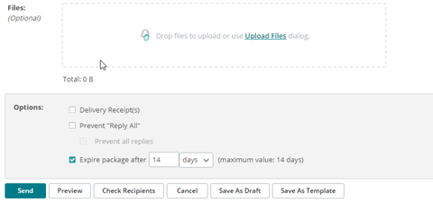
Figure 6: Screenshot
- Options: Here is where you can set when the package will expire. The max days to set a package before it expires is 14 days. After the package expires, it will disappear from your sent items and from the receiver’s inbox.
- You can choose to send, preview, check recipients, etc.
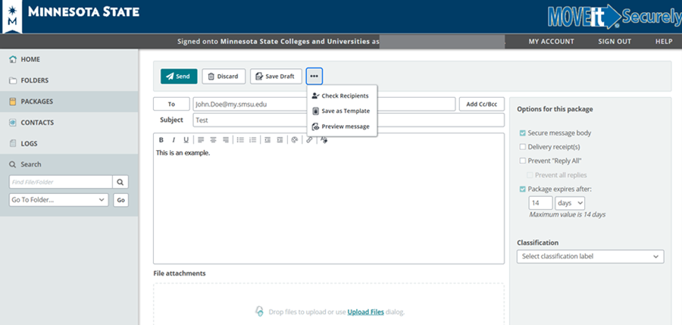
Figure 7: Screenshot
- After you send:
If the recipient is in the SMSU address book, they should be able to log in with their StarID and password.
If this was a name you had to add to the “To” line, a username and password will be shown to you. You will see the package ID, username (the email that was pasted) and a generated password at the bottom of the next screen after clicking on send. This information will need to be sent to the receiver.
- If the recipient is in the SMSU address book, they should be able to log in with their StarID and password.
- If this was a name you had to add to the “To” line, a username and password will be shown to you. You will see the package ID, username (the email that was pasted) and a generated password at the bottom of the next screen after clicking on send. This information will need to be sent to the receiver.
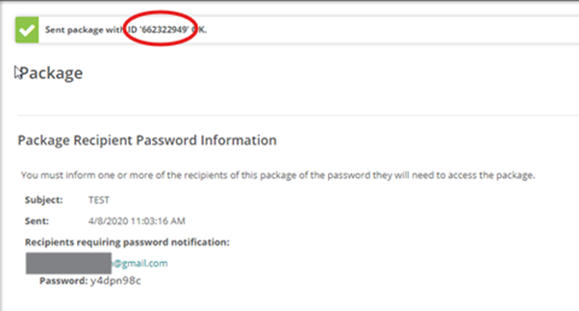
Figure 8: Screenshot
The recipient will also receive notification that a package is waiting for them, and they will need to click on the link and log in to Move it Securely using the username and password sent to them.

MoveItSecurely Recipient Instruction
If you have recently received a file and would like to access it, please follow the steps below.
- You will receive an email that a package is waiting for you.
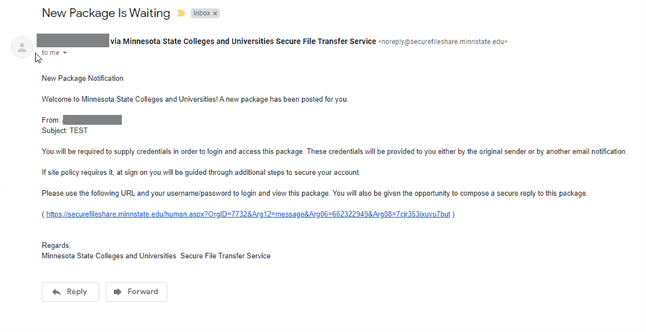
Figure 9: Screenshot
- You will need to click on the link and log in to MoveItSecurely using either
your starID and starID password
or using the username (the email the file was sent through) and password sent to you if your email address is NOT an SMSU issued email address (e.g., yahoo, Gmail, Hotmail etc.). If this is the case, you will be required to change the password after logging in.
Click Continue when password change is successful
- your starID and starID password
- or using the username (the email the file was sent through) and password sent to you if your email address is NOT an SMSU issued email address (e.g., yahoo, Gmail, Hotmail etc.). If this is the case, you will be required to change the password after logging in.
Click Continue when password change is successful

Figure 10: Screenshot
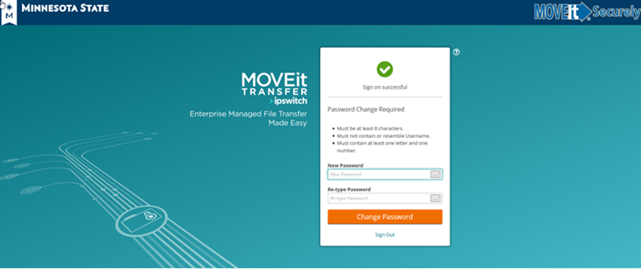
Figure 11: Screenshot
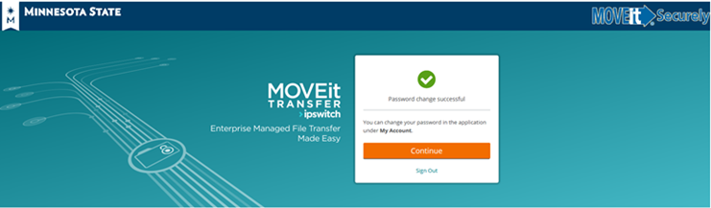
Figure 12: Screenshot
- After signing in go to packages

Figure 13: Screenshot
- Click on Inbox and select package
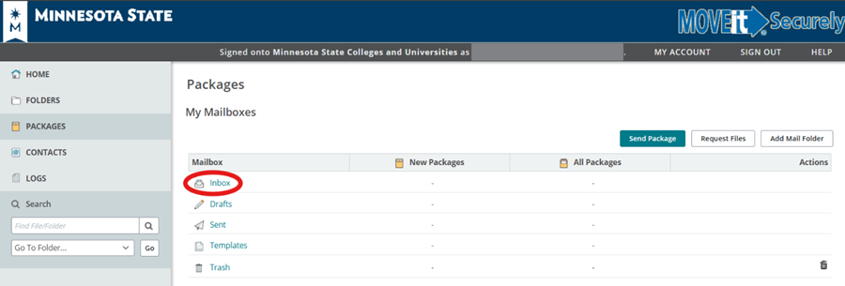
Figure 14: Screenshot
- You will be able to read the content of the email or access any attached files. If the message contains information/attachments that you would like to retain, it is recommended that you download and store the file in a safe location as soon as possible. After a maximum of 14 days, the email and the attached file will be deleted and cannot be accessed unless the sender resends it.

How to setup MFA for Fileshare aka MoveitSecurely
- Please login to your Move It Securely account.
- Click “My Account” in the grey bar.
- The first set of options is for Multi-Factor Authentication (MFA)
- Click the “Enable” button next to the option you would like to use.
- If you click the enable button next to the Authenticator App, it will show a QR Code. Click the link next to “Can’t Scan the QR Code?” that says “Show Code”
Open the app and tap the three vertical dots menu, then tap “Add Account”.
Tap “other account”
It will then ask for you to scan a QR Code, tap “OR ENTER CODE MANUALLY”
For account name, put in your StarID
For Secret Key, put in the code from the Move It Securely website.
After entering the code, it will bring you back to the main screen, tap your StarID account name, and it will show you a 6-digit code to enter into the Move IT Securely Website.
The website will then show you Enabled next to the Authenticator App.
- Open the app and tap the three vertical dots menu, then tap “Add Account”.
- Tap “other account”
- It will then ask for you to scan a QR Code, tap “OR ENTER CODE MANUALLY”
- For account name, put in your StarID
- For Secret Key, put in the code from the Move It Securely website.
- After entering the code, it will bring you back to the main screen, tap your StarID account name, and it will show you a 6-digit code to enter into the Move IT Securely Website.
- The website will then show you Enabled next to the Authenticator App.
- If you click the enable button next to the Email choice, it will send you a 6-digit code to your email to enable MFA. Once the code is entered, MFA will be enabled for email.
- You can have one or the other enabled, but not both.
Accessibility Review & Update Log:
- [x] Content accuracy and link integrity verified
- [x] High-contrast visual hierarchy implemented (Inter and Calibri)
- [x] Image alt-text captions verified (all screenshots captioned)
- [x] PDF attachments scraped and fully inlined directly inside the document
- [x] Outline headers and standard list sequences optimized for screen readers

